High-Level Design
DBSCAN Anomaly Detection — Cross-Domain File Transfer Monitoring
Companion: Detailed Level Design (DLD) — Complete SPL Query Reference, All Layers
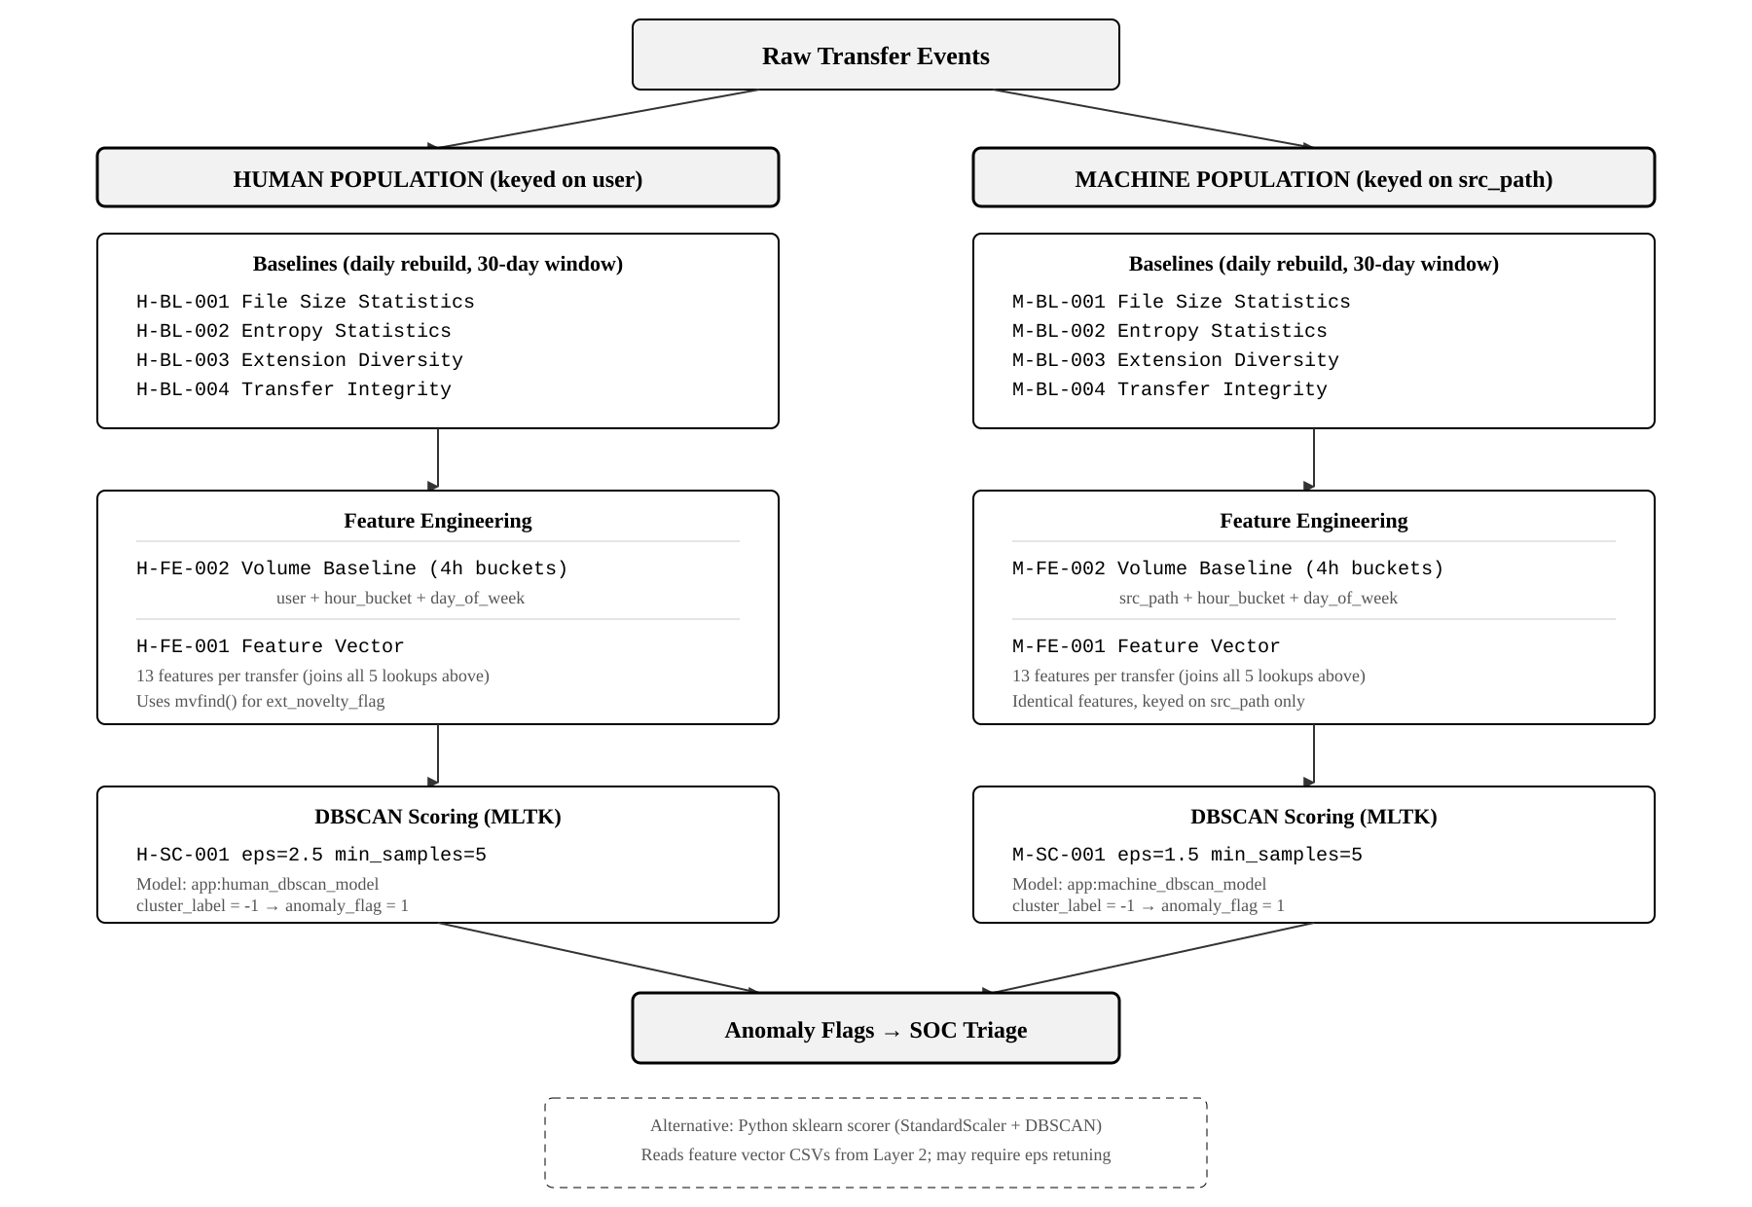
Figure 1: Three-layer pipeline architecture with dual-population separation
14 lookup tables across 3 layers. 8 baselines (Layer 1), 4 feature engineering (Layer 2), 2 DBSCAN scoring (Layer 3). Human population keyed on user; machine population keyed on src_path (confirmed 1-to-1 with service accounts in production). 13-feature vectors computed per transfer. DBSCAN noise points (cluster_label = -1) flagged as anomalies for SOC triage.
Primary scoring via Splunk MLTK; alternative Python sklearn scorer (StandardScaler + DBSCAN) available for external validation. Mermaid source provided as companion file.

Design Summary
Purpose. This system detects anomalous cross-domain file transfers indicative of data exfiltration by computing behavioural baselines per entity, engineering a 13-dimensional feature vector from those baselines, and applying DBSCAN clustering to identify transfers that deviate from established patterns. It operates within Splunk using SPL and the Machine Learning Toolkit.
Dual-Population Architecture. Human and machine populations are modelled separately at every layer. Human behaviour is variable (timing, file types, volumes driven by work patterns) and clusters loosely; machine behaviour is predictable (fixed schedules, consistent file types) and clusters tightly. A single model would mask machine anomalies and over-flag normal human variance. The test environment splits populations using a population field; production will require a service account lookup table or naming convention filter.
Layer 1: Baselines. Eight lookup tables (four per population) compute descriptive statistics over a rolling 30-day window across four signal dimensions: file size, Shannon entropy, file extension diversity, and transfer integrity (SendEventCount vs ReceiverEventCount ratios). Rebuilt daily via scheduled searches. Each applies a metric-appropriate stdev floor to prevent division-by-zero in downstream z-score computation: 1 byte (file size), 0.1 (entropy), 0.5 (extension count), 0.05 (integrity ratio).
Layer 2: Feature Engineering. Four lookups. The volume baselines (FE-002, one per population) compute transfer frequency statistics using 4-hour time buckets — chosen over 1-hour granularity because the latter produced sparse baselines with unreliable stdev values. The feature vector queries (FE-001) join each raw transfer against all five upstream lookups and compute 13 features: file_size_zscore, file_size_ratio, entropy_zscore, entropy_ratio, ext_diversity_zscore, ext_novelty_flag (uses mvfind() against the multivalue ext_list), ext_rarity_score, integrity_ratio, integrity_zscore, missing_event_flag, volume_zscore, size_entropy_interaction, and composite_deviation_score (RMS of z-scores).
Layer 3: DBSCAN Scoring. Two scoring lookups apply MLTK DBSCAN to the feature vectors. Human model uses eps=2.5 (looser, accommodating natural variance); machine model uses eps=1.5 (tighter, reflecting predictable behaviour). Both use min_samples=5. Parameters are specified inline in the | fit DBSCAN command. Transfers assigned to cluster -1 (noise) are flagged as anomalies. Fitted models are saved for reuse via | apply. The Python sklearn alternative applies StandardScaler before DBSCAN fitting, which changes the effective distance metric and may require eps retuning.
Production Deployment. All queries currently use earliest=-30d@d for testing. Baseline queries should retain this value; feature vector and scoring queries must be reduced to the production log rotation interval so only new transfers are scored per run. The population field filter must be replaced with an appropriate production mechanism. DBSCAN models should be retrained periodically as baseline behaviour evolves. Duration and transfer rate features are excluded pending source data validation but can be added without structural changes.

